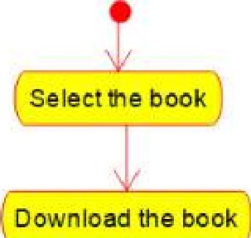

|  |  |  |  |  |  |  |  |  |
| --- | --- | --- | --- | --- | --- | --- | --- | --- |
|  | |  |  | | --- | --- | |  |  | | See the number of pages present | | |  |  | |  |

